Course Name | ITD 2313-60025 – Script Programming
Instructor | Ken Dewey
Student Name | Jake Salmon
Due date | <assignment due date here>
Grade | <grade earned here>
Grading Comments | <instructor comments here>

Textbook Assignments - Week 1

Page 55
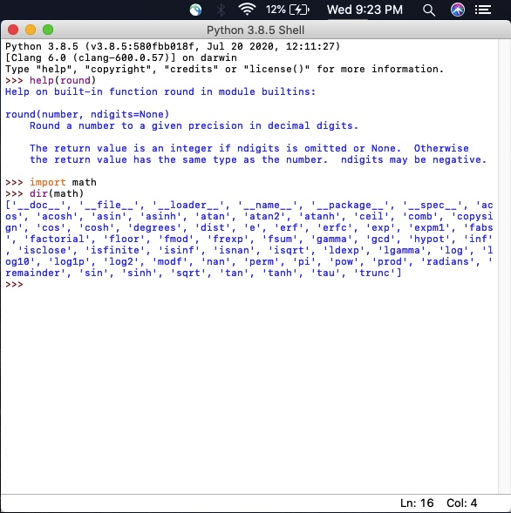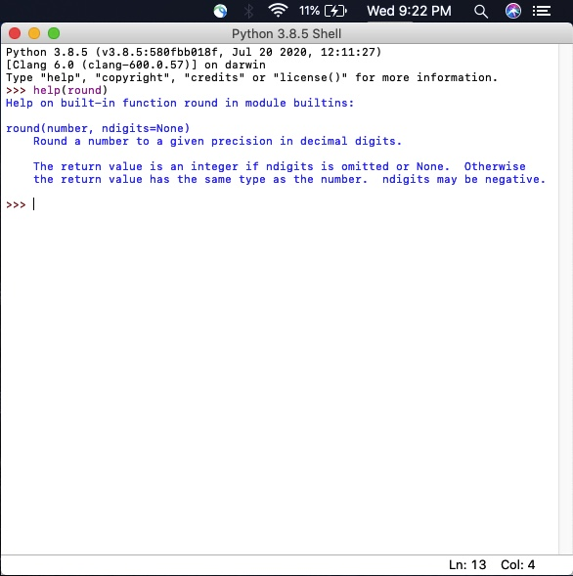

Page 56
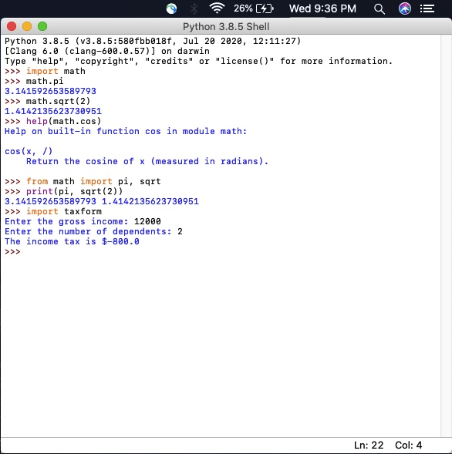

Page 57

